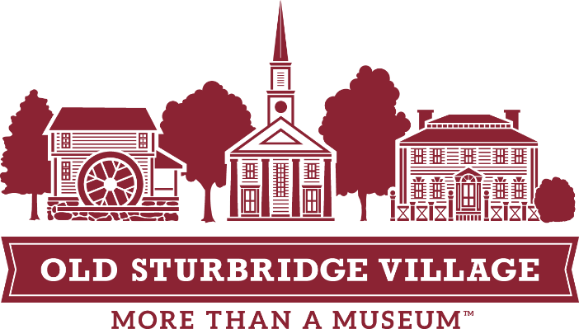
What to Expect:
The Town Meeting Program for Educators

Introduction: upon arrival
Concluding discussion: begins at 12:30 (unless arrangements are made for an earlier time)

Before your visit:
  - Make sure to complete the Town Meeting pre-visit lesson with your students before coming to the Village. The pre-visit lesson provides background information on Town Meetings and the treatment of the poor during the 19th century. The Town Meeting itself will run much more smoothly and be more engaging for students if they are well-prepared. You can find the pre-visit materials here: http://www.osv.org/education/field-trips/town-meeting-poor-relief-in-the-1830s.

When you arrive:
For this program, you may be instructed to check in at the Visitor Center instead of Museum Education. You will receive an email prior to the program with further instructions. Your buses may park in the main museum parking lot. You may store lunches in the small wooden building outside of the Visitor Center, carry them with you during your visit, or leave them in the Museum Education lunchroom.
After the lead teacher checks in at the Visitor Center or Museum Education, your group will be escorted to the Center Meetinghouse by a museum educator, where they will receive a short, 5–10-minute introduction about the Town Meeting Program. During this time, Museum Education staff will remind the students of their mission during their visit; pose some questions for the group to ask; and pass out a worksheet, pencil, and Village map for them to use to gather information.
The introduction will typically take place in the Center Meetinghouse. The staff member who greets your buses will remind you of the introduction.

During your visit:
During your time in the Village, the students should be asking costumed interpreters their thoughts about whether the town of Old Sturbridge should start a poor farm or continue the use of the vendue system to take care of those who cannot take care of themselves. They can take notes on the worksheet provided during the introduction. All Village staff can help answer their questions about the poor farm issue. Which method of relief is best for the community? How did peoples’ opinions about relief change depending on their occupations or social class? What are some of the pros and cons of each method?
Most groups have about 1.5 to 2 hours in the Village before the actual Town Meeting takes place.

The Town Meeting:
The culminating Town Meeting takes place at 12:30 at the Center Meetinghouse, unless you have arranged a different time. You will be informed of the location during your introduction. The Town Meeting is facilitated by a Museum staff member, and all the students are asked to take on the role of a citizen of Old Sturbridge. Students are expected to voice their opinion on the poor farm issue and then vote on what is best for their community. The Town Meeting itself usually runs 30 to 45 minutes, depending on student discussion.
If you are planning on eating lunch during your visit, make sure that students leave enough time to eat before heading over to the Town Meeting location for 12:30.

After your visit:
  - There is a post-visit lesson included in the Town Meeting materials, found here: http://www.osv.org/education/field-trips/town-meeting-poor-relief-in-the-1830s.
Please feel free to reach out to us with any questions or comments!

Liz O’Grady
Director of Museum Education, Field Trip and Youth Programs
Old Sturbridge Village
eogrady@osv.org
(508) 347-0287

