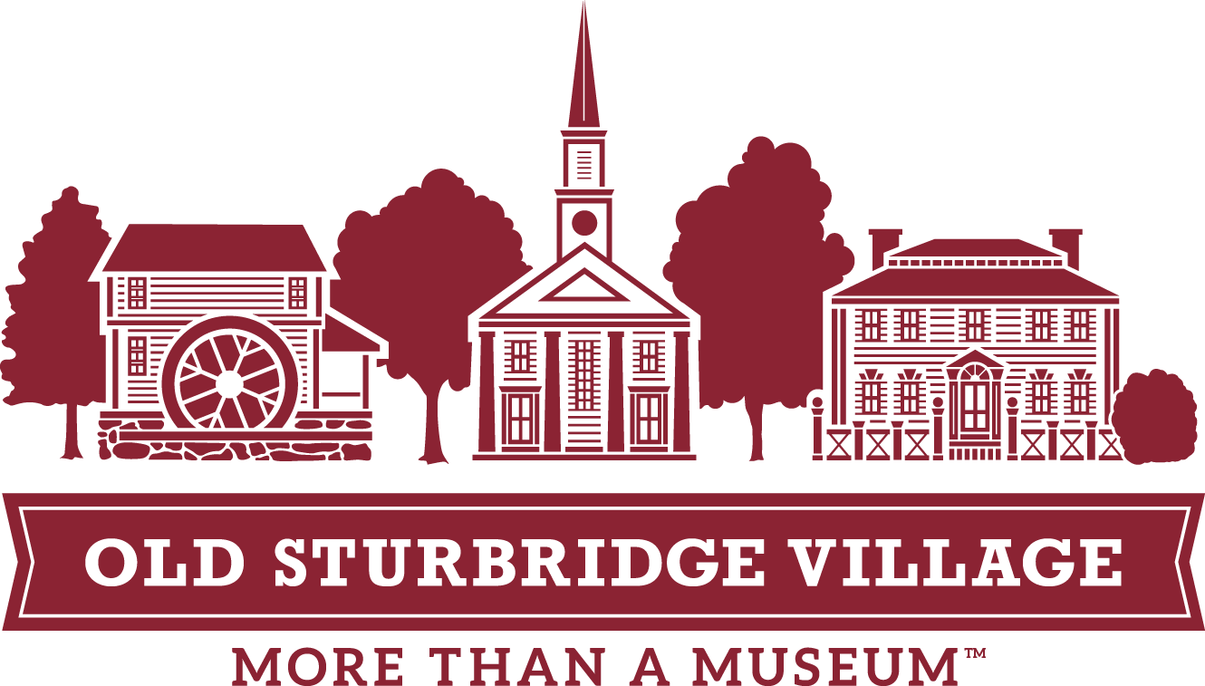
What to Expect:
Abolition and Social Change Program

Registering for an Abolition and Social Change Program:
Register for a self-guided visit for your class or school through our field trip website here: https://www.osv.org/education/field-trips/.
On the Explorable Places registration site, you will be able to see where there is program availability and choose slots for your class. A few things to note about registering:
- Each booking online is for a class-sized group of 25. You will add additional classes to accommodate your student body. For example, if you are bringing 100 students, you will register for four classes using the green “ADD CLASSROOM” button.
- The form also has spots to note the number of chaperones, both school staff and non-teacher chaperones.
- On the registration form, make sure to note your arrival and departure time, as well as any special accommodations your group might require.
- Your group will be divided into smaller groups of 8 to 12 students for this program.
- This program is delivered in a tour format with guided discussion.
Before your visit:
- Make sure to review and share the Chaperone Guide to OSV, which can be found on our website here: https://www.osv.org/education/field-trips/abolition-and-social-change/.
- There are pre-visit lesson plans to use with your students before coming to the Museum. You can see these materials here: https://www.osv.org/education/field-trips/abolition-and-social-change/.
When you arrive:
When you arrive at Museum Education, your buses will be greeted by Museum Educators, who will lay out the guidelines for your visit. The lead teacher should head inside Museum Education to the ticketing office, where they will confirm numbers, pay for the visit (if necessary), and receive maps and stickers for chaperones. Please make sure that you know the exact numbers of students, non-teacher chaperones, and school staff chaperones before coming to check in. No refunds will be made for drops in visitor numbers.
If you brought lunches, students can put those in the lunchroom on the metal shelves before heading into the Village. On busy field trip visitation days, you may receive an assigned lunchtime at check-in.
Please make sure to dispose of any trash or cardboard containers after lunch.
During your Program:
Participants will break up into smaller groups of 8 to 12 students. They will receive a brief introduction about the Abolition and Social Change Program from an educator. During this time, Museum Education staff will remind the students of their mission during their visit; pose some questions for the group to ask; and pass out a worksheet, pencil, and Village map for them to use to gather information.
- Each group will be asked to go to at least three of the Village sites in a specific order, but may visit more on the list if time allows. Each building has a series of primary sources to examine, as well as questions or group discussion prompts.
- Groups may also visit other buildings in the Village that are not on the list, but these sites will not have primary sources to analyze.
- A note on language: All of the primary sources we use in this program are from the early 19th century. Some of the primary sources that the students will interact with use language that was commonplace in the 1800s and we know to be offensive and hurtful today. During discussion, OSV educators will use modern terminology regarding race and slavery.

The Guided Discussion:
The culminating guided discussion takes place at 12:30. You will be informed of the location during your introduction. The guided discussion is facilitated by a Museum staff member. The discussion itself usually runs about 30 minutes, depending on student participation.
If you are planning on eating lunch during your visit, make sure that students leave enough time to eat before heading over to the discussion location for 12:30.
After your visit:
There are also two post-visit lessons for after your visit, if you would like to utilize these resources. One focuses on poetry; the other on music. They are located here: https://www.osv.org/education/field-trips/abolition-and-social-change/.
Please feel free to reach out to us with any questions or comments, and we look forward to your visit!
Liz O’Grady
Director of Education, Field Trips & Youth Programs
Old Sturbridge Village
eogrady@osv.org
(508) 347-0287

